Character Outlines

Human 1: Jedi Investigator

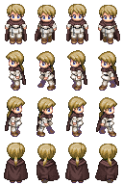

NPC 1 (Innocent): Bounty Hunter   
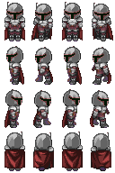

NPC 2 (Innocent): Info Droid  
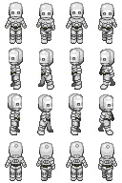

NPC 3 (Innocent): Green alien girl

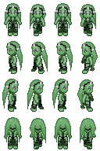

NPC 4 (Innocent): Local Human

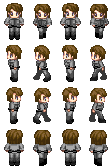

NPC 5 (Innocent): Foreign Diplomat

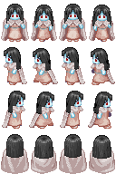

NPC 6 (Guilty):

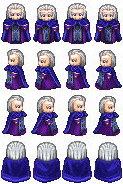 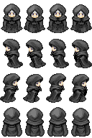

NPC 7 (Police):

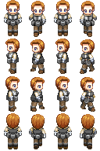

NPC 8 (Police):

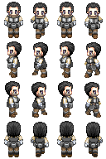

NPC 9 (Police Chief):  
